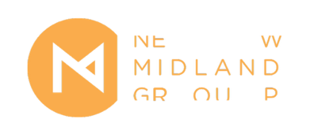
New Midland Group Website Designer | Application Form
Application Deadline: Sunday 24 January 2021, 5pm

Please complete the application form and submit alongside a CV (optional) & up to 3 examples of current and / or previous projects that you feel are relevant to your application. These examples could be links to websites, images (JPEG, 2MB max. file size), GIFs or videos. Vimeo or YouTube links are accepted.

Please submit your application to colette@weareprimary.org. The email subject line should read NMG Website Designer Opportunity – [Your Name].

Applicant Information:

- This opportunity is specifically for website designers living or professionally based in the Midlands. Information on which areas and counties are classified by Arts Council England as existing in the Midlands can be found here.
- We are happy to accommodate alternative approaches to the application process. Please contact us if you would like to submit an audio or video response, need the application form in a different format, or have any specific access needs that you would like to discuss.
- We positively encourage people from Black, Asian and Minority Ethnic backgrounds and those who face cultural, social, or economic barriers, or who self-identify as disabled to apply.
- Please ensure that you send a completed equal opportunities monitoring form with your application.

For more information or to discuss any concerns relating to the Applicant Information please contact colette@weareprimary.org.
Application Form
Applicant Information
Name:
Contact Details: | Email:  Phone Number:  Address:  Postcode:
Preferred Pronouns:
Website Design Proposal (max 350 words.)
Please tell us your vision for the New Midland Group Website. Please refer to the Open Call document for details of what NMG are looking for in the new site…
The current website can be accessed here - http://newmidlandgroup.co.uk.

Supporting Statement (max 250 words.)
With reference to your interests and practice as a designer, please tell us why you are applying for this opportunity…

Additional Materials
You are invited to submit up to 3 examples of current and / or previous projects that you feel are relevant to your application. These examples could be links to websites, images (JPEG, 2MB max. file size), GIFs or videos. Vimeo or YouTube links are accepted.

If you would like to include links please feel free to add the links here…

Additional Support
Please let us know if you have any access or additional support needs that you would like the team to know about…

Please confirm that the information contained within this form is accurate to the best of your knowledge by adding your name or electronic signature below.
Signature of Applicant: |  | Date:

Thank you for taking the time to complete this application. Please direct any inquiries to colette@weareprimary.org. We look forward to hearing from you.

NMG City Pilot Programme is delivered by New Midland Group & supported by Arts Council England, through National Lottery Project Grants
