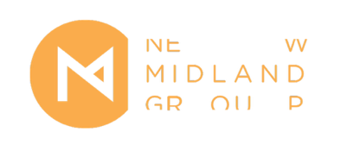

New Midland Group Equal Opportunities Monitoring Form
We are collecting this data because we have a commitment to reflecting diversity in our consortium, and to creating an inclusive, safe, and supportive environment. This data helps us to evaluate the effectiveness and fairness of our recruitment and selection procedures. This information will be kept separate from your application form and will be treated in the strictest confidence.
- Which of the following best describes your gender identity?
  - Female
  - Male
  - Non-binary
  - If you prefer to use another term, please let us know here…
_______________
  - Prefer not to say
- What is your age?
  - 0-19
  - 20-34
  - 35-49
  - 50-64
  - 65+
  - Prefer not to say
- Do you have a long-term health condition, or identify as a d/Deaf or disabled person?
  - Yes
  - No
  - Prefer not to say
- Which of the following best describes your ethnicity?
  - Arab
  - Black African
  - Black Caribbean
  - Another Black background
  - Indian
  - Pakistani
  - Bangladeshi
  - Chinese
  - Another Asian background
  - White & Asian
  - White & Black African
  - White & Black Caribbean
  - Another Mixed background
  - White British
  - White Irish
  - Gypsy or Irish Traveller
  - Another White background
  - Another ethnic group, please let us know here…
_______________
  - Prefer not to say
- Where did you hear about this opportunity?
  - Arts Jobs
  - A-N
  - New Midland Group’s website
  - Backlit’s website
  - One Thoresby Street’s website
  - Primary’s website
  - Social media
  - Other (please detail)…
_________________

